Project
#include <iostream>
#include <conio.h>
#include <windows.h>
#include <cstdlib>
#include <string>
#include <fstream>
using namespace std;

const int rows = 35;
const int cols = 26;
char map[rows][cols];
char previousMap[rows][cols];
void menu();
void instructions();
void viewHighscores();

int playerrow = rows - 2;
int playercol = cols / 2;
int enemyrow = 0, enemycol = 0;
int lives = 3;
int score = 0;
int distancecovered = 0;
string playerName;

void gotoxy(int x, int y) {
COORD coord;
coord.X = x;
coord.Y = y;
SetConsoleCursorPosition(GetStdHandle(STD_OUTPUT_HANDLE), coord);
}

void drawmap() {
for (int i = 0; i < rows; i++) {
for (int j = 0; j < cols; j++) {
if (i == 0 || i == rows - 1)
map[i][j] = '-';
else if (j == 0 || j == cols - 1)
map[i][j] = '|';
else
map[i][j] = ' ';
previousMap[i][j] = ' ';
}
}
}

void displaymap() {
for (int i = 0; i < rows; i++) {
for (int j = 0; j < cols; j++) {
if (map[i][j] != previousMap[i][j]) {
gotoxy(j, i);
cout << map[i][j];
previousMap[i][j] = map[i][j];
}
}
}
}
void clearplayer() {
if (playercol > 1 && playercol < cols - 2) {
map[playerrow][playercol - 1] = ' ';
map[playerrow][playercol] = ' ';
map[playerrow][playercol + 1] = ' ';
}
}

void addplayer() {
if (playercol > 1 && playercol < cols - 2) {
map[playerrow][playercol - 1] = '<';
map[playerrow][playercol] = '|';
map[playerrow][playercol + 1] = '>';
}
}

void generateasteroids() {
static int counter = 0;
counter++;
if (counter >= 3) {
int y = rand() % (cols - 3) + 1;
if (map[1][y] == ' ') {
map[1][y] = '#';
}
counter = 0;
}
}
void moveasteroids() {
for (int i = rows - 2; i >= 1; i--) {
for (int j = 1; j < cols - 1; j++) {
if (map[i][j] == '#') {
if (map[i + 1][j] == ' ') {
map[i + 1][j] = '#';
map[i][j] = ' ';
}
else if (map[i + 1][j] == '-') {
map[i][j] = ' ';
}
}
}
}
}

void collisionwithasteroids() {
for (int i = rows - 2; i >= 1; i--) {
for (int j = 1; j < cols - 1; j++) {
if (map[i][j] == '#') {
if (map[i + 1][j] == '<' || map[i + 1][j] == '|' || map[i + 1][j] == '>') {
map[i][j] = ' ';
lives--;
}
}
}
}
}

void generatecoins() {
static int counter = 0;
counter++;
if (counter >= 3) {
int y = rand() % (cols - 3) + 1;
if (map[1][y] == ' ') {
map[1][y] = '$';
}
counter = 0;
}
}
void movecoins() {
for (int i = rows - 2; i >= 1; i--) {
for (int j = 1; j < cols - 1; j++) {
if (map[i][j] == '$') {
if (map[i + 1][j] == ' ') {
map[i + 1][j] = '$';
map[i][j] = ' ';
}
else if (map[i + 1][j] == '-') {
map[i][j] = ' ';
}
}
}
}
}

void collisionwithstars() {
for (int i = rows - 2; i >= 1; i--) {
for (int j = 1; j < cols - 1; j++) {
if (map[i][j] == '$') {
if (map[i + 1][j] == '<' || map[i + 1][j] == '|' || map[i + 1][j] == '>') {
map[i][j] = ' ';
score += 10;
}
}
}
}
}
void addenemy() {
enemyrow = playerrow + 2;
enemycol = playercol;
map[enemyrow][enemycol] = '|';
map[enemyrow][enemycol + 1] = '|';
map[enemyrow][enemycol - 1] = '|';

}
void enemyjump() {
enemyrow += 2;
map[enemyrow][enemycol] = '|';
map[enemyrow][enemycol + 1] = '|';
map[enemyrow][enemycol - 1] = '|';

}
void clearenemy() {
map[enemyrow][enemycol] = ' ';
map[enemyrow][enemycol + 1] = ' ';
map[enemyrow][enemycol - 1] = ' ';
}
void instructions() {
char inp;
system("cls");
cout << "\t....Instructions....";
cout << "\n Endless Runner: Obstacle Dash";
cout << "\n\n Press ESC to go back";

cout << "\n\n ::Gameplay Overview::\n";
cout << "\n 1. Use A/D to move left/right.";
cout << "\n 2. W to jump, S to crouch, J to long jump.";
cout << "\n 3. Avoid asteroids (#), collect coins ($).";
cout << "\n 4. Score increases with coins. Game gets faster over time.";
cout << "\n 5. Collisions with obstacles cost lives.";
cout << "\n 6. Game ends when lives reach 0.";
cout << "\n 7. Your high score is saved.";

inp = _getch();
if (inp == 27) {
menu();
}
}
void viewHighscores() {
system("cls");
cout << "====== High Scores ======\n";

ifstream file("scores.txt");
string name;
int s, d;
while (file >> name >> s >> d) {
cout << name << "\tScore: " << s << "\tDistance: " << d << "\n";
}
file.close();

cout << "\nPress any key to return...";
_getch();
}

void startGame();

int main() {
menu();
return 0;
}

void startGame() {

cout << " WELCOME TO THE GAME " << endl;
cout << "Enter your name: ";
getline(cin, playerName);

playerrow = rows - 2;
playercol = cols / 2;
enemyrow = 0;
enemycol = 0;
lives = 3;
score = 0;
distancecovered = 0;

srand(time(0));
drawmap();
system("cls");

while (true) {
if (_kbhit()) {
char ch = _getch();
clearplayer();
if (distancecovered > 2000)
clearenemy();

if (ch == 'a' && playercol > 2)
playercol--;
else if (ch == 'd' && playercol < cols - 3)
playercol++;
else if (ch == 'w')
playerrow--;
else if (ch == 's')
playerrow++;
else if (ch == 'j')
playerrow -= 2;
}

if (playerrow < rows - 10)
playerrow = rows - 10;
if (playerrow > rows - 2)
playerrow = rows - 2;

generateasteroids();
moveasteroids();
collisionwithasteroids();
generatecoins();
movecoins();
collisionwithstars();

if (distancecovered == 2000) {
clearplayer();
addenemy();
playerrow += 2;
}

addplayer();
displaymap();

gotoxy(cols + 2, 2);
cout << "Distance: " << distancecovered;
gotoxy(cols + 2, 3);
cout << "Lives: " << lives;
gotoxy(cols + 2, 4);
cout << "Score: " << score;

distancecovered += 10;

int delay = 200;
if (distancecovered >= 1000)
delay = 100;
if (distancecovered > 2000) {
if (playerrow > rows - 4)
playerrow = rows - 4;
addenemy();
delay = 70;
}

if (lives <= 0)
break;

Sleep(delay);
}

system("cls");
cout << "\n\tGame Over!";
cout << "\n\tFinal Score: " << score;
cout << "\n\tDistance Covered: " << distancecovered;
cout << "\n\tRemaining Lives: " << lives << "\n";

ofstream file("scores.txt", ios::app);
if (file.is_open()) {
file << playerName << " " << score << " " << distancecovered << "\n";
file.close();
}

cout << "\nPress any key to return to the main menu...";
_getch();
}

void menu() {
while (true) {
system("cls");
cout << "======== MAIN MENU ========\n";
cout << "1. Start Game\n";
cout << "2. Instructions\n";
cout << "3. View Highscores\n";
cout << "4. Exit\n";
cout << "Choose an option: ";

char choice = _getch();
if (choice == '1') {
system("cls");
startGame();
}
else if (choice == '2') {
instructions();
}
else if (choice == '3') {
viewHighscores();
}
else if (choice == '4') {
exit(0);
}
}
}

Menu

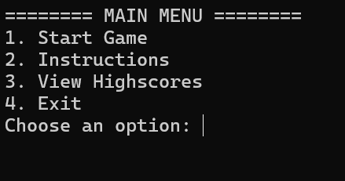

Game
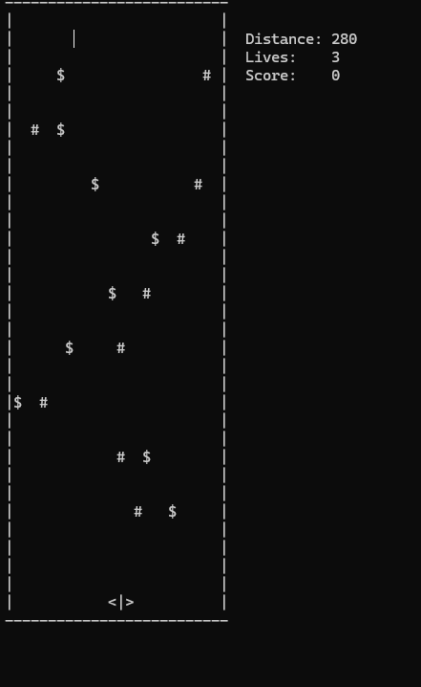
End
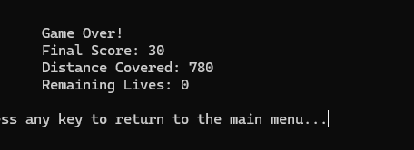

Chatgpt help

